LAB EXPERIMENTS
ECA1410 – EMBEDDED SYSTEM

EXP – 1
FLASHING OF LED USING AT89C51 MICROCONTROLLER USING PROTEUS
AIM:
To Write an assembly language program to flash the LED using AT89C51
SOFTWARES REQUIRED:
• Proteus software
PROGRAM
ORG 0000H
UP: SETB P2.0
ACALL DELAY
CLR P2.0
ACALL DELAY
SJMP UP
DELAY: MOV R4,#35
H1:MOV R3,#255
H2:DJNZ R3,H2
DJNZ R4,H1
RET
END

OUTPUT:
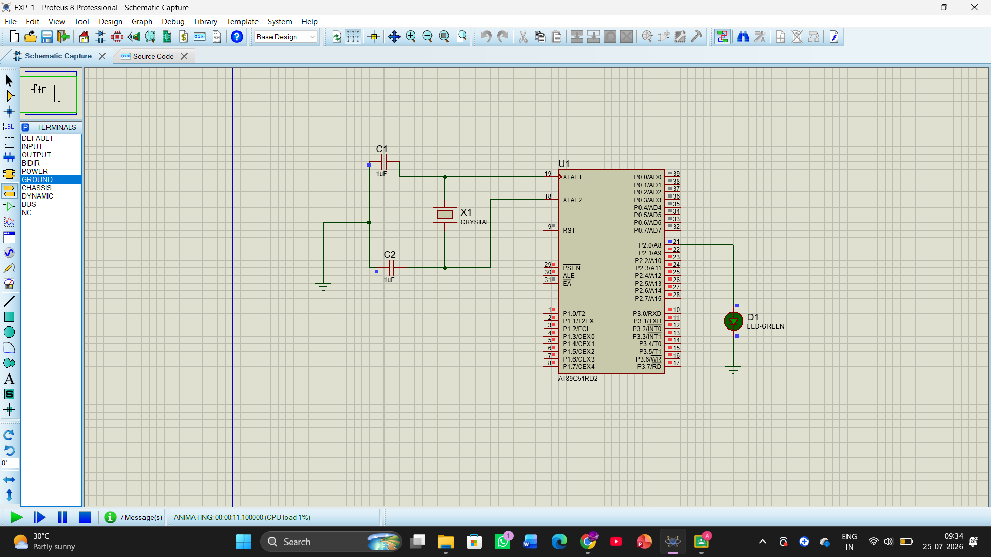
RESULT:
Thus the program has been successfully verified and executed.
EXP- 2:
GENERATION OF SQUARE WAVE USING PROTEUS

AIM:
To write an assembly language program to Generate square wave using
AT89C51.
SOFTWARE REQUIRED:
• Proteus 8 software
PROGRAM
ORG 0000H
UP: SETB P2.0
ACALL DELAY
CLR P2.0
ACALL DELAY
SJMP UP
DELAY: MOV R4,#35
H1:MOV R3,#255
H2:DJNZ R3,H2
DJNZ R4,H1
RET
END
OUTPUT:
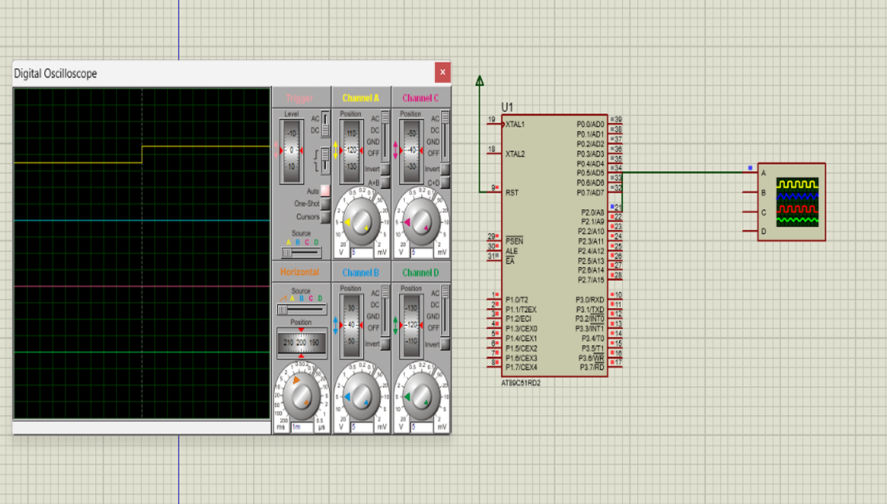
RESULT:
Thus the program has been successfully verified and executed.
EXP – 3:
AIM:
To write an assembly language program for Stepper Motor Using AT89C51 using Keil and
Proteus
SOFTWARE REQUIRED:
• Proteus 8 software.
PROGRAM:
ORG 0000H
UP: MOV P2,#09H
ACALL DELAY
MOV P2,#0CH
ACALL DELAY
MOV P2,#06H
ACALL DELAY
MOV P2,#03H
ACALL DELAY
SJMP UP
DELAY:MOV R4,#18
H1:MOV R3,#255
H2:DJNZ R3,H2
DJNZ R4,H1
RET
END
OUTPUT:
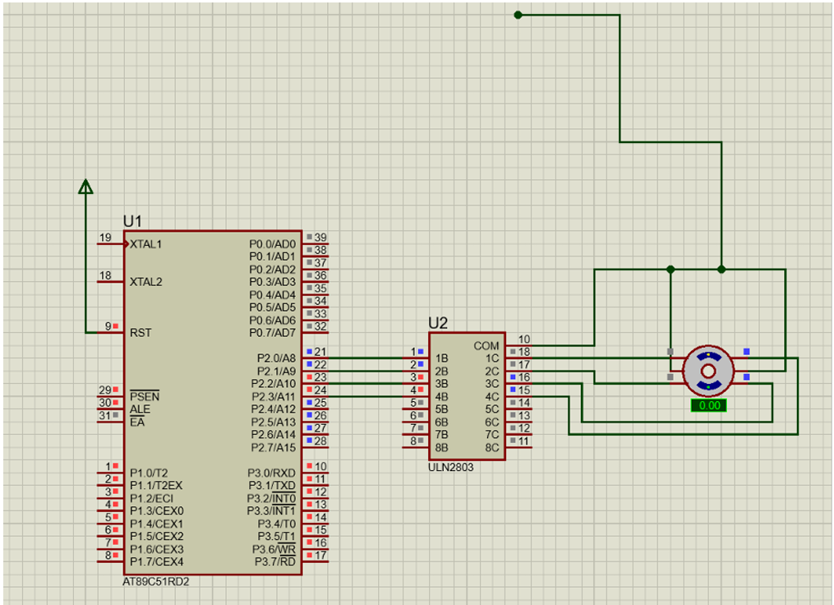
RESULT:
Thus the program has been successfully verified and executed.

Exp No: 4

7 SEGMENT DISPLAY USING AT89C51 USING PROTEUS
AIM:
To write an assembly language program for 7 Segment Display Using AT89C51 using Keil and Proteus

SOFTWARE REQUIRED:
• Proteus 8 software.
PROGRAM:
ORG 000H
UP:MOV P2,#0C0H
ACALL DELAY
MOV P2,#0F9H
ACALL DELAY
MOV P2,#0A4H
ACALL DELAY
MOV P2,#0B0H
ACALL DELAY
MOV P2,#99H
ACALL DELAY
MOV P2,#92H
ACALL DELAY
MOV P2,#82H
ACALL DELAY
MOV P2,#0F8H
ACALL DELAY
MOV P2, #80H
ACALL DELAY
MOV P2,#90H
ACALL DELAY
DELAY: MOV R5,#10
H1:MOV R4,#180
H2:MOV R3,#255
H3:DJNZ R3,H3
DJNZ R4,H2
DJNZ R5,H1
RET
END
OUTPUT:
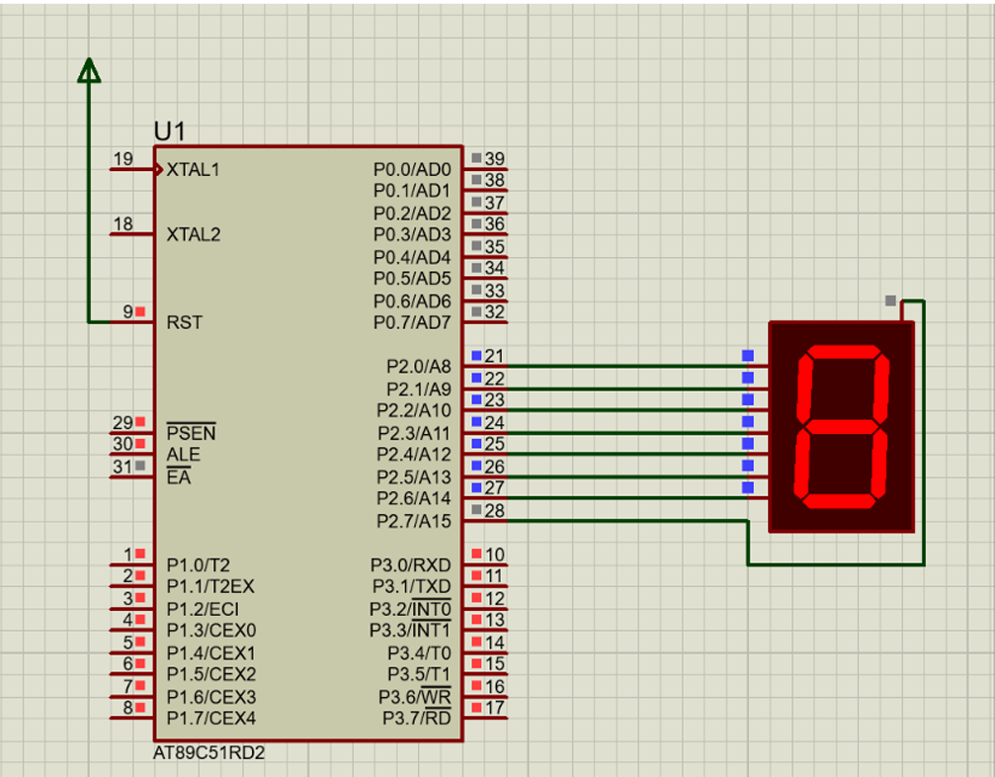
RESULT:
Thus the program has been successfully verified and executed.
Exp No: 9
ARDUINO BASED MANUAL ELECTRONIC COUNTER USING
PROTEUS AIM:
To write an Embedded C program for Manual Electronic counter using Arduino IDE and
Proteus
SOFTWARE REQUIRED:
• Proteus 8 software
• Arduino IDE

OUTPUT:
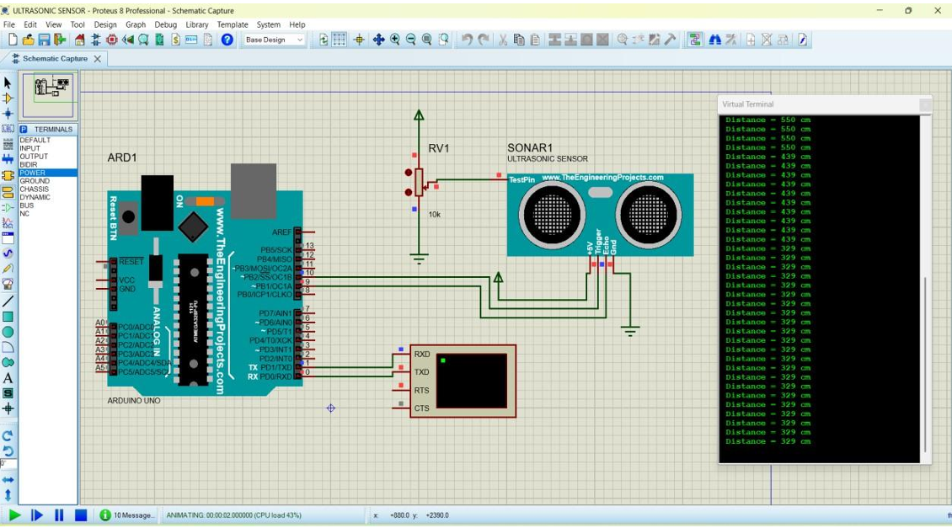
RESULT:
Thus the program has been successfully verified and executed.
Exp No: 6
ARDUINO TO 16x2 LCD DISPLAY USING PROTEUS
AIM:
To write an Embedded C program to interface Arduino Uno and 16 x 2 LCD display using
Arduino Uno and Proteus
SOFTWARE REQUIRED:
• Proteus 8 software.
• Arduino IDE software
PROGRAM:
Arduino to 16x2 LCD Display using Proteus
#include &lt;LiquidCrystal.h&gt;
LiquidCrystal lcd (7, 8, 9, 10, 11, 12);
// your PWM numbers may be different

void setup() {
lcd.begin(16, 2);
lcd.print(&quot;put your message here&quot;);
}
void loop () {
for (int i=0; 1&lt;13; i++)
lcd.scrollDisplayLeft();
delay(700);
}
}
OUTPUT:
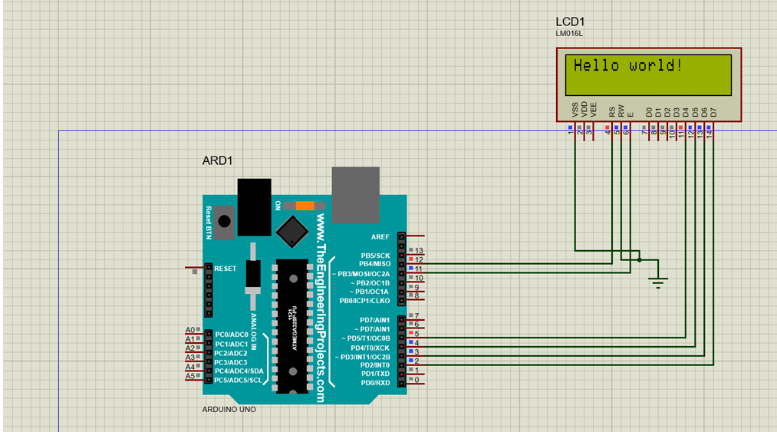
RESULT:
Thus the program has been successfully verified and executed.
Exp No: 8
GAS SENSOR MQ-2 IN PROTEUS USING ARDUINO
AIM:
To write an Embedded C program for interfacing Gas Sensor MQ-2 using Arduino Uno and Proteus
SOFTWARE REQUIRED:
• Proteus 8 software.
• Arduino IDE software
PROGRAM:
#define GreenLed 13
#define Sensor A0
void setup(){
pinMode(13,OUTPUT);
pinMode(12,OUTPUT);
pinMode(A0,INPUT);
Serial.begin(9600);
}
void loop() {
int value = analogRead(A0);
Serial.print(&quot;Analogic Value coming from the sensor : &quot;);
Serial.println(value);
delay(100);
if(value&gt;600){
digitalWrite(13,HIGH);
}
else{
digitalWrite(13,LOW);
}
delay(20);
}
Code for MQ6 sensor:
int mq6Pin = A0; // MQ-5 analog pin connected to A0
void setup() {
Serial.begin(9600);
void loop() {
int sensorValue = analogRead(mq5Pin);
Serial.print(&quot;MQ5 Sensor Value: &quot;);
Serial.println(sensorValue);
delay(1000); // 1-second delay
}
OUTPUT:
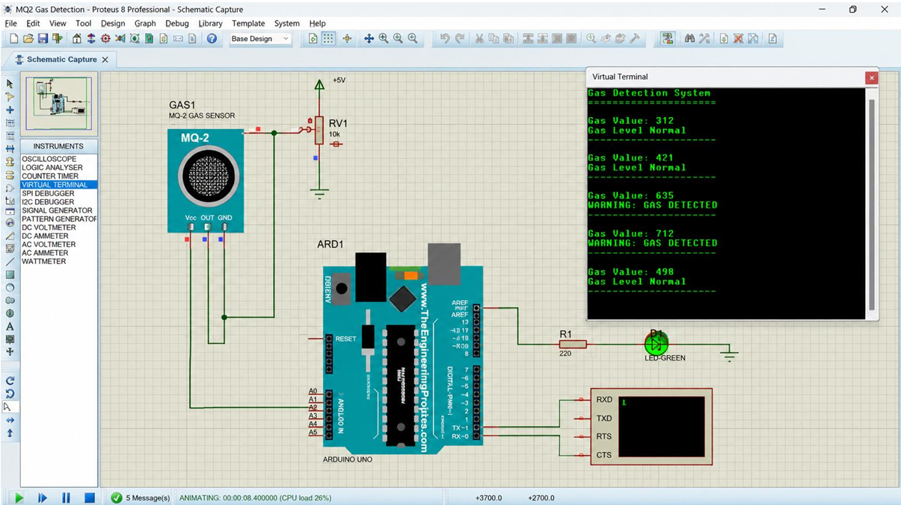
RESULT:
Thus the program has been successfully verified and executed.
Exp No: 7
SERIAL COMMUNICATION USING ARDUINO WITH
PROTEUS AIM:
To write an Embedded C program for serial communication using Arduino Uno and Proteus
SOFTWARE REQUIRED:
• Proteus 8 software.
• Arduino IDE software
PROGRAM:
void setup()
{
Serial.begin(9600); // send and receive at 9600 baud
}
int number = 0;
void loop()
{
Serial.print(&quot;Number is &quot;);
Serial.println(number); // print the number
delay(500); // delay half second between numbers
number++; // to the next number
}
OUTPUT:
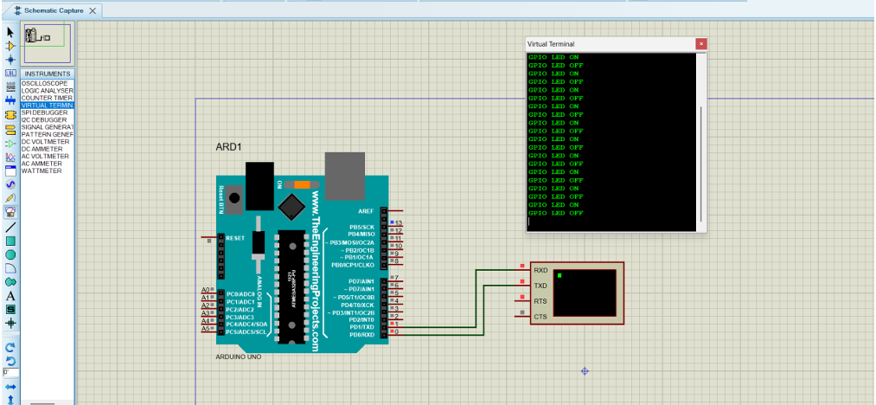
RESULT:
Thus the program has been successfully verified and executed.
Exp No:
ULTRASONIC SENSOR IN PROTEUS USING ARDUINO
AIM:
To write an Embedded C program for interfacing Ultrasonic Sensor using Arduino Uno
and Proteus
SOFTWARE REQUIRED:
• Proteus 8 software.
• Arduino IDE software
PROGRAM:
// Program Sketch
int trig = 10;
int echo = 9;
long duration;
int cm;
void setup() {
// put your setup code here, to run once:
pinMode(trig, OUTPUT);
pinMode(echo,INPUT);
Serial.begin(9600);
}

void loop() { // Sketch to calculate ultrasonic distance
digitalWrite(trig, LOW);
delayMicroseconds(10);
digitalWrite(trig, HIGH);
delayMicroseconds(10);
digitalWrite(trig, LOW);
delayMicroseconds(10);
duration = pulseIn(echo, HIGH);
cm = (duration/2) * 0.034;
// Print Value on Serial Monitor
Serial.print(&quot; Distance = &quot;);
Serial.print(cm);
Serial.println(&quot; cm&quot;);
}
OUTPUT:
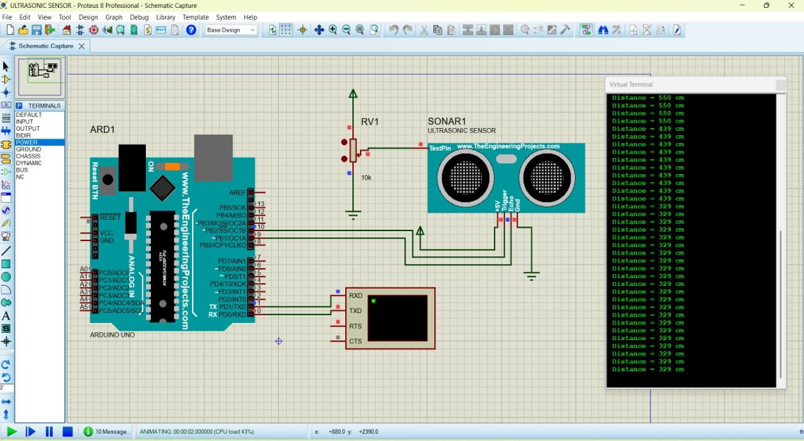
RESULT:
Thus the program has been successfully verified and executed.
Exp No: 10
PIR SENSOR IN PROTEUS USING ARDUINO
AIM:
To write an Embedded C program for interfacing PIR Sensor using Arduino Uno and Proteus
• Proteus 8 software.
• Arduino IDE software
PROGRAM:
int Status = 13; // Digital pin D6
int sensor = 12; // Digital pin D7
void setup() {
Serial.begin(9600);
pinMode(sensor, INPUT); // declare sensor as input
pinMode(Status, OUTPUT); // declare LED as output
}
void loop() {
long state = digitalRead(sensor);
Serial.println(state);
if(state == HIGH) {
digitalWrite (Status, HIGH);
Serial.println(&quot;Motion detected!&quot;);
delay(1000);
}
else {
digitalWrite (Status, LOW);
Serial.println(&quot;Motion absent!&quot;);
delay(1000);
}
}
OUTPUT: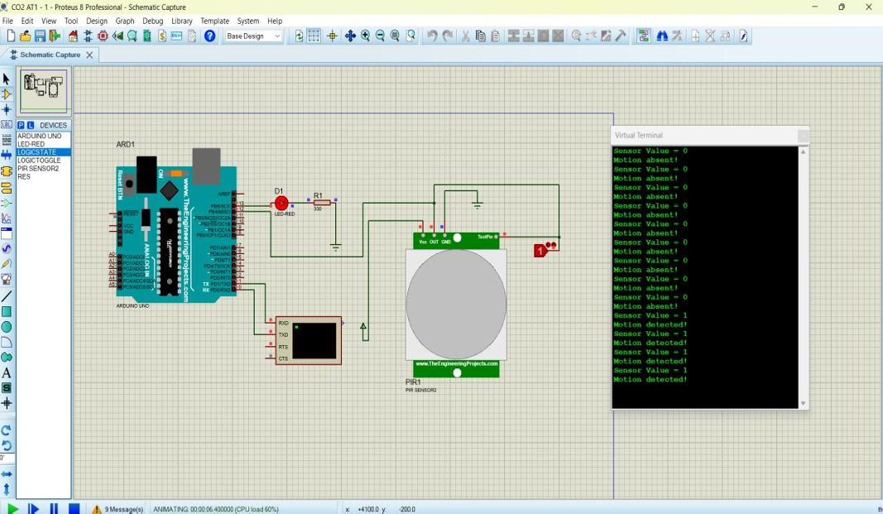

RESULT:
Thus the program has been successfully verified and executed.

